
NOTE: This is an official document by Indexademics. Unless otherwise stated, this document may not be accredited to individuals or groups other than the club IDX, nor should this document be distributed, sold, or modified for personal use in any way.
IDX G9 CHEMISTRY S STUDY GUIDE ISSUE 8
By Emma, Edited by Gorden

8.2 Molecular compounds
I. Molecules and Molecular Compounds
- A molecule is a neutral group of atoms joined together by covalent bonds
- An oxygen molecule is an example of a diatomic molecule—a molecule that contains two atoms
- Molecules can also be made of atoms of different elements
- A compound composed of molecules is called a molecular compound
II. Representing Molecules
- A molecular formula is the chemical formula of a molecular compound
- A molecular formula shows how many atoms of each element a substance contains
- A molecular formula reflects the actual number of atoms in each molecule
- The subscripts are not necessarily the lowest whole-number ratios
- Butane (C4H10) is also a molecular compound
- molecular formula does not show the molecule’s structure
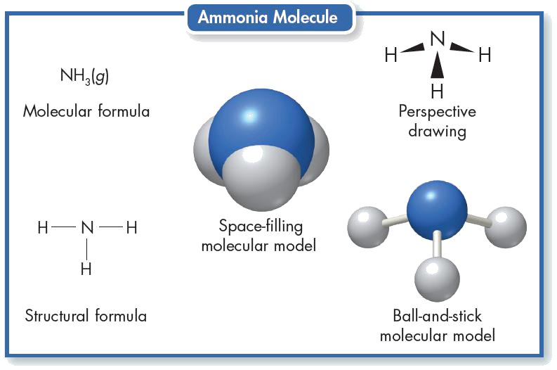
- Ball-and-stick model shows three-dimensional structure of molecule
- A ball represents an atom’s nucleus and inner-level electrons
- Sticks represents bonds, Straight stick represents single bonds; curved springs represent multiple bonds
- The arrangement of atoms within a molecule is called its molecular structure
III. Comparing Molecular and Ionic Compounds
- Representative unit:
- Molecular compound: molecule
- Ionic compound: formula unit
- A formula unit is the lowest whole-number ratio of ions in an ionic compound
- Melting point:
- Molecular compounds tend to have relatively lower melting and boiling points than ionic compounds
- Many molecular compounds are gases or liquids at room temperature
- Types of component element
- Metal + Nonmetal → Ionic compound
- Nonmetal + Nonmetal → Molecular compound

8.3 Bonding Theories
I. VESPR Theory
- In order to explain the three-dimensional shape of molecules, scientists use valence-shell electron-pair repulsion theory (VSEPR theory)
- VSEPR theory states that the repulsion between electron pairs causes molecular shapes to adjust so that the valence-electron pairs stay as far apart as possible.
- In short, valence electron pairs stay as far apart as possible because they repel.
- Linear: In a linear molecule, the atoms can be connected by a straight line
- 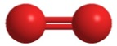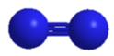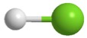
HCl
N₂
O₂

- Bond angle is the geometric angle between two adjacent bonds
- Trigonal Planar: A trigonal planar molecule has a triangular, flat shape (120 degrees angle)
- eg: boron trichloride (BCl₃)
- The three pairs electrons are arranged as far apart as possible
- Tetrahedral: A tetrahedral molecule has four surfaces (109.5 degrees angle)
- The four pairs electrons are arranged as far apart as possible
- The hydrogens in a methane molecule are at the four corners of a geometric solid called a regular tetrahedron
- 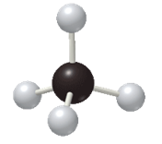
- In this arrangement, all of the H–C–H angles are 109.5°. This also goes with other tetrahedral molecules.
- 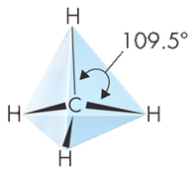
- Pyramidal: The four pairs electrons are arranged as far apart as possible (107 degrees angle)
- The nitrogen in ammonia (NH₃) is surrounded by four pairs of valence electrons, one of which is an unshared pair.
- 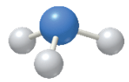
- The unshared pair strongly repels the bonding pairs, pushing them together.
- 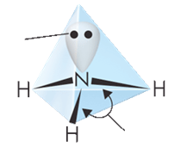
107⁰
unshared pair
- Both tetrahedral and pyramidal shapes have four pairs of electrons surrounding the central atom, and the unshared pairs exert a greater repulsion force, thus the bond angle in pyramidal is slightly less than in tetrahedral shape.
- In short words, unshared pairs “takes up more space” and causes the others to “squeeze”
- Bent: The four pairs electrons are arranged as far apart as possible(two other atoms and has two unshared electrons)
- The bond angle in bend shape is 105⁰

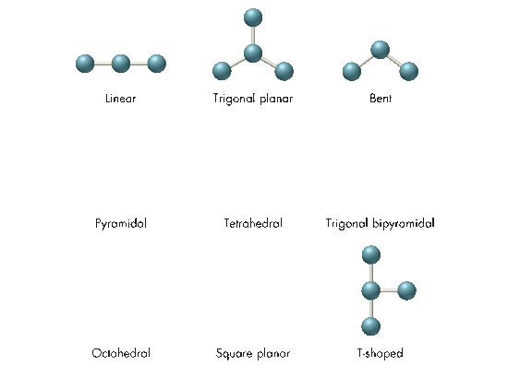
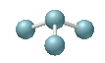
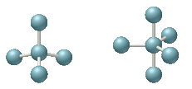
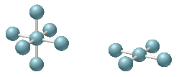
Linear
Trigonal planar
Bent
Pyramidal
Tetrahedral
Trigonal
bipyramidal
Octahedral
Square
planar
- Shape of Larger Molecules:
- The shape of larger molecules is determined by the bond angle of each central atom.
- 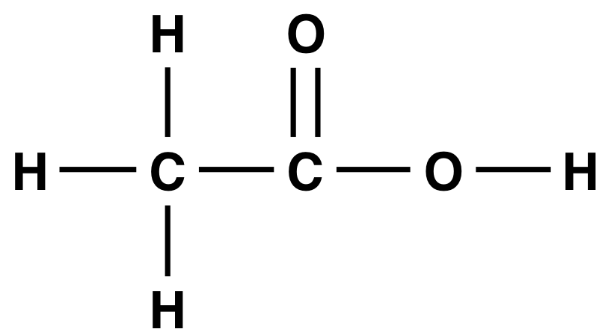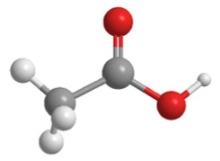
- eg: bond angle on
- 1st carbon is 109.5⁰ (tetrahedral)
- 2nd carbon is 120^{0 (pyramidal)}
- 3rd oxygen is 105^{0 (bent)}
II. Hybrid orbitals
- When an atom approaches another atom to form bond, the atomic orbitals mix together, forming hybrid orbitals
- In hybridization, several atomic orbitals mix to form the same total number of equivalent hybrid orbitals.

- Molecular shape | - Number of Orbitals | - Hybrid Orbitals
- Linear | - 2 | - sp
- Trigonal Planar | - 3 | - sp²
- Tetrahedral, pyramidal, bent(105º) | - 4 | - sp³

9.1-9.3 Naming Ionic Compounds and Molecular Compounds
1. Monatomic ions
- consist of a single atom with a positive or negative charge resulting from the loss or gain of one or more valence electrons
- The names of cations are the same as the elements, followed by the word ion or cation.
- Anion names start with the stem of the element name and end in –ide
- Two methods are used to name metals that form more than one ion
- Stock system: Place a Roman numeral in parentheses
- Ex: Fe2+ -> iron(II) ion Fe3+ -> iron(III) ion
- Root word
- Ex: Fe2+ -> ferrous ion Fe3+ -> ferric ion
2. Polyatomic ions
- Composed of more than one atom
- Behaves as a unit and carry a charge
- ended with suffix –ate for ions with more oxygen atoms. (Example: Chlorate, ClO3-)
- ended with suffix –ite for ions with less oxygen atoms (Example: Chlorite, ClO2-)
- add prefix –per and plus suffix –ate for ions with greatest number of oxygen atoms (Example: Perchlorate, ClO4-)
- add prefix –hypo and plus suffix –ite for ions with fewest number of oxygen atoms (Example: Hypochlorite, ClO-. Note that -hypo is pronounces the same as “hypa”)
3. Binary Ionic Compounds
- To write the formula of a binary ionic compound, first write the symbol of the cation and then the anion. Then add subscripts as needed to balance the charge
- Crisscross method (AxBy)
- To name any binary ionic compound, place the cation name first, followed by the anion name
- If the metallic element in a binary ionic compound has more than one common ionic charge, a Roman numeral must be included. Example: Cu2+ is Copper (II)
4. Compounds with polyatomic ions
- Whenever more than one polyatomic ion is needed to balance the charges in an ionic compound, use parentheses to set off the polyatomic ion in the formula
5. Binary Molecular Compounds
- Write the names of the elements in the order listed in the formula
- Use prefixes appropriately to indicate the number of each kind of atom
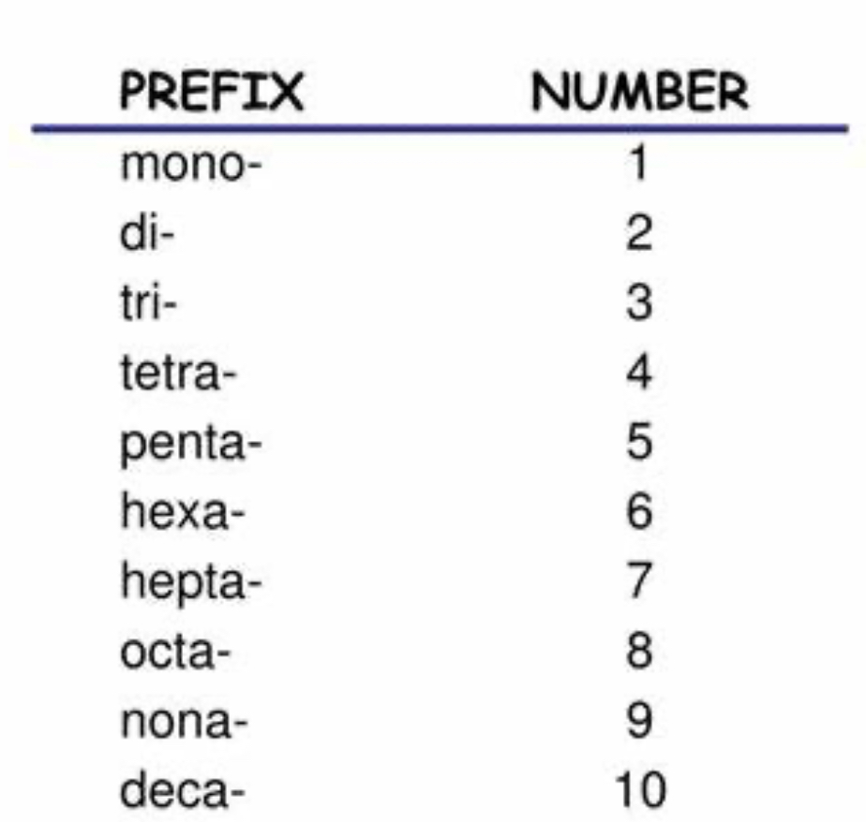
- End the name of the second element with the suffix –ide (Example: Carbon Tetrabromide is CBr4)
- If just one atom of the first element is in the formula, omit the prefix mono- for that element (Example: Carbon Monoxide is CO)
- Also, the vowel at the end of a prefix is sometimes dropped when the name of the element begins with a vowel (Example: pentoxide, not pentaoxide)
9.4 Naming and Writing Formulas for Acids and Bases
- Acid is a compound that contains one or more hydrogen atoms and produces hydrogen ions when dissolved in water
- A base is compound that produces hydroxide ions when dissolved in water (generally is an ionic compound)
- The name of the cation is followed by the name of the anion

